PROJECT REPORT OF INDUSTRY ORIENTED HANDS ON EXPERIENCE (IOHE)
ON
<Enhancing Healthcare with Edge AI in Medical Imaging>
submitted in partial fulfilment of the requirements for the award of degree of

BACHELOR OF ENGINEERING
In
COMPUTER SCIENCE AND ENGINEERING

Submitted by: Supervised By:
Khushi (2210991795) Dr. Rajat Takkar
Vaani(2210990930)
Kartikay Singh Manhas (2210991761)
Kashish Sharma (2210991770)


DEPARTMENT OF COMPUTER SCIENCE AND ENGINEERING
CHITKARA UNIVERSITY INSTITUTE OF ENGINEERING AND TECHNOLOGY
CHITKARA UNIVERSITY, PUNJAB, INDIA

CONTENTS

S.NO. | Title | Page No.
 | Abstract | 1
 | Introduction | 2
 | Methodology | 3 - 4
 | Tools and Technologies | 5
 | Implementation | 6
 | Major Findings/Outcomes | 7 - 8
 | Snapshots | 9 - 10
 | Conclusion and Future Scope | 11 - 12
 | References | 13 - 14
 | Appendices | 15

DECLARATION

I hereby certify that the work which is being presented in the project report entitled “Enhancing Healthcare with Edge AI in Medical Imaging” in partial fulfilment of requirement for the award of the degree of Bachelor of Engineering (Computer Science and Engineering) submitted in the department of Computer Science and Engineering at Chitkara University Institute of Engineering and Technology, Chitkara University, Punjab, India, is an authentic record of my own work carried out under the supervision of Dr. Rajat Takkar. The matter presented in this project report has not been submitted in any other university/institute for the award of any degree.

Place: Rajpura Khushi (2210991795)
Date: 05-05-2026 Vaani (2210990930)
Kartikay Singh Manhas (2210991761)
Kashish Sharma (2210991770)

This is to certify that the above statement made by the candidate is correct to the best of my knowledge and belief.

(Dr. Rajat Takkar)
<Assistant Professor>
Department of Computer Science and Engineering
Chitkara University Institute of Engineering and Technology,
Chitkara University, Punjab, India

ACKNOWLEDGEMENT

I would like to express my sincere gratitude to our guide and faculty members of the Department of Computer Science Engineering , Chitkara University Institute of engineering and Technology, for their continuous support and guidance throughout this research work.
I also thank my teammates for their cooperation,dedication and valuable contributions to the successful completion of this report.
Lastly, I am grateful to my family and friends for their encouragement and motivation during the project.

List Of Figures

Figure Number | Figure Title
Figure 1 | Architecture Overview of Edge AI
Figure 2 | Development & Deployment using Edge AI in Medical Imaging
Figure 3 | Python Program
Figure 4 | Experimental Setup for Edge AI-Based Medical Imaging System

List of Tables

Table Number | Table Title
Table 1 | Evolution of Medical Imaging Over the Past Century

Abstract

Edge Artificial Intelligence (AI) is transforming the healthcare industry by enabling real-time medical image analysis and faster diagnostic decision-making. This report explores the application of Edge AI in medical imaging and its impact on diagnostic accuracy, efficiency, and treatment decisions. The integration of Artificial Intelligence (AI), Machine Learning (ML), and medical imaging technologies such as MRI, CT scans, X-rays, ultrasound, and PET scans has improved disease detection and reduced human errors.
The report highlights how Edge AI processes medical data locally on healthcare devices instead of relying completely on cloud computing. This ensures low latency, better privacy, and quick diagnosis, especially in emergency and rural healthcare environments. The study also examines the role of Convolutional Neural Networks (CNNs), Electronic Health Records (EHR), and Computer-Aided Diagnosis (CAD) systems in modern healthcare diagnostics.
Additionally, the report discusses ethical challenges, data privacy concerns, and the need for secure healthcare systems. Experimental analysis using chest X-ray datasets demonstrates the effectiveness of Edge AI-based diagnostic systems. The findings indicate that Edge AI has significant potential to improve patient outcomes, support medical professionals, and revolutionize healthcare diagnostics.

1
Introduction

Artificial Intelligence (AI) and Machine Learning (ML) are among the most powerful technologies used in healthcare today. Medical imaging techniques such as MRI, CT scans, ultrasound, and X-rays play an important role in diagnosing diseases. However, traditional diagnostic systems often face issues such as human errors, delayed analysis, and difficulty handling large amounts of data.
AI and ML help overcome these limitations by analyzing medical images with high accuracy and identifying abnormalities that may not be visible to the human eye. Machine learning models continuously improve their performance through data learning and pattern recognition.
Recently, Edge AI has emerged as a revolutionary technology in healthcare. Unlike traditional cloud-based AI systems, Edge AI processes data directly on local devices such as imaging machines and portable healthcare systems. This enables real-time diagnosis, faster treatment decisions, improved privacy, and reduced dependence on internet connectivity.
The integration of AI with Electronic Health Records (EHR) and clinical decision support systems further enhances personalized healthcare and improves patient outcomes.
Additionally, AI and ML technologies support predictive analytics and early disease detection by analyzing large volumes of patient data efficiently. These intelligent systems assist healthcare professionals in monitoring patient conditions, recommending suitable treatments, and improving overall hospital management. With continuous advancements in deep learning and neural networks, AI-driven healthcare systems are becoming more reliable, cost-effective, and capable of delivering high-quality medical services to patients worldwide.

2
Methodology
Research Design:
The study uses both qualitative and quantitative research methods to evaluate Edge AI in medical imaging. Quantitative analysis focuses on performance metrics such as accuracy, precision, and efficiency, while qualitative analysis includes surveys and interviews with healthcare professionals.
Data Collection:
Data was collected using:
- Medical imaging datasets (CT, MRI, Ultrasound, X-rays)
- Surveys and questionnaires
- Clinical repositories and healthcare records
- Publicly available datasets such as Kaggle Chest X-ray datasets
Data Preprocessing:
Medical images were normalized and labeled before training the AI model. Preprocessing techniques helped reduce variability and improve feature representation.
Normalization formula:
$$X^{'}=\frac{X-μ}{σ}$$

3
Algorithm Training:
Convolutional Neural Networks (CNNs) were used for training the model. The loss function and optimization techniques such as Stochastic Gradient Descent (SGD) were applied.
Loss Function:
$$L(θ)=\frac{1}{N}\sum_{i=1}^{N}{l(f(}X_{i};θ),Y_{i})$$
Optimization Formula:
$$θ=θ-η∇_{θ}L(θ)$$
Accuracy Formula:
$$Accuracy=\frac{TP+TN}{TP+TN+FP+FN}$$

Deployment:
The trained AI model was deployed on edge devices such as embedded GPUs and AI accelerators integrated into medical devices. The system provides real-time diagnosis and supports clinical decision-making.

4
Tools and technologies
Software Tools:
- Python
- TensorFlow
- Keras
- OpenCV
- Jupyter Notebook
Technologies Used:
- Artificial Intelligence (AI)
- Machine Learning (ML)
- Edge AI
- Deep Learning
- Convolutional Neural Networks (CNN)
- Electronic Health Records (EHR)
Hardware Components:
- Embedded GPUs
- Portable X-ray systems
- Ultrasound devices
- AI accelerators
Dataset Used:
- Chest X-ray Dataset for Pneumonia Detection
- Source: Kaggle

5
Implementation
Edge AI Architecture:
The implementation includes multiple layers:
- Medical Device Layer
- Edge AI Processing Layer
- Decision and Interaction Layer
- Cloud/Hospital Network Layer
The Edge AI system processes medical data locally, reducing latency and improving privacy.
Experimental Setup:
The model was trained using chest X-ray images for pneumonia detection. CNN algorithms were used to classify images into normal and pneumonia categories.
Workflow:
- Data Collection
- Data Preprocessing
- Model Training
- Model Evaluation
- Deployment on Edge Devices
Python Implementation:
The project used Python-based deep learning libraries for image classification and real-time medical image analysis.
6
Major Finings/Outcomes
- Edge AI significantly improves diagnostic speed and accuracy.
Edge AI enables healthcare systems to process medical data directly on local devices without sending it to remote cloud servers. This reduces response time and allows doctors to receive diagnostic results much faster. By using advanced AI algorithms, Edge AI also improves the accuracy of disease detection and supports early diagnosis, which is critical for effective treatment.
- Real-time image processing reduces treatment delays.
With real-time image processing, medical scans such as MRI, CT scans, and X-rays can be analyzed instantly. This helps healthcare professionals identify abnormalities immediately and begin treatment without unnecessary waiting time. Faster analysis is especially important in emergency situations where quick medical decisions can save lives.
- AI-based systems minimize human errors in diagnosis.
Traditional diagnostic methods may sometimes lead to errors due to fatigue, lack of experience, or oversight by medical professionals. AI-powered diagnostic systems reduce these risks by analyzing medical images consistently and accurately. These systems can detect even small abnormalities that may be difficult for the human eye to notice.
- CNN models effectively detect abnormalities in medical images.
Convolutional Neural Networks (CNNs) are highly effective deep learning models used in medical imaging analysis. CNNs automatically learn important image features and patterns, making them capable of identifying diseases such as tumors, fractures, infections, and other abnormalities with high precision. Their performance improves continuously with more training data.
- Edge AI works efficiently even in low-connectivity environments.
Unlike cloud-based systems that require stable internet access, Edge AI performs data processing locally on healthcare devices. This makes it highly suitable for remote and rural areas where internet connectivity may be weak or unavailable. Healthcare services can continue without interruption even in offline conditions.

7
- Local data processing improves patient privacy and security. Edge AI keeps sensitive patient information on local devices instead of transferring it over the internet to external servers. This reduces the risk of data breaches, cyberattacks, and
unauthorized access. As a result, patient privacy is better protected and healthcare organizations can maintain stronger data security standards.
- Integration with EHR enhances personalized treatment plans.
When AI systems are integrated with Electronic Health Records (EHR), they can analyze a patient’s medical history, test reports, and treatment patterns more effectively. This helps doctors create personalized treatment plans tailored to individual patient needs, improving overall healthcare quality and patient outcomes.
- Portable diagnostic devices are useful in rural and emergency healthcare.
Edge AI-powered portable healthcare devices can perform medical analysis directly at the patient’s location. These devices are extremely beneficial in rural areas, ambulances, disaster zones, and emergency situations where access to advanced hospital infrastructure may be limited. They provide quick and reliable healthcare support anytime and anywhere.
- The system reduces dependency on cloud infrastructure.
Since Edge AI performs computation locally, it reduces the need for continuous cloud communication and large-scale cloud storage. This lowers bandwidth usage, decreases operational costs, and improves system reliability. Healthcare facilities can continue functioning efficiently even if internet services are disrupted.
- Edge AI supports healthcare professionals in better clinical decision-making.
AI-driven healthcare systems provide doctors with accurate insights, predictive analysis, and decision-support recommendations based on patient data. These intelligent tools assist healthcare professionals in making faster and more informed clinical decisions, ultimately improving diagnosis quality, treatment effectiveness, and patient care.

8

Snapshots

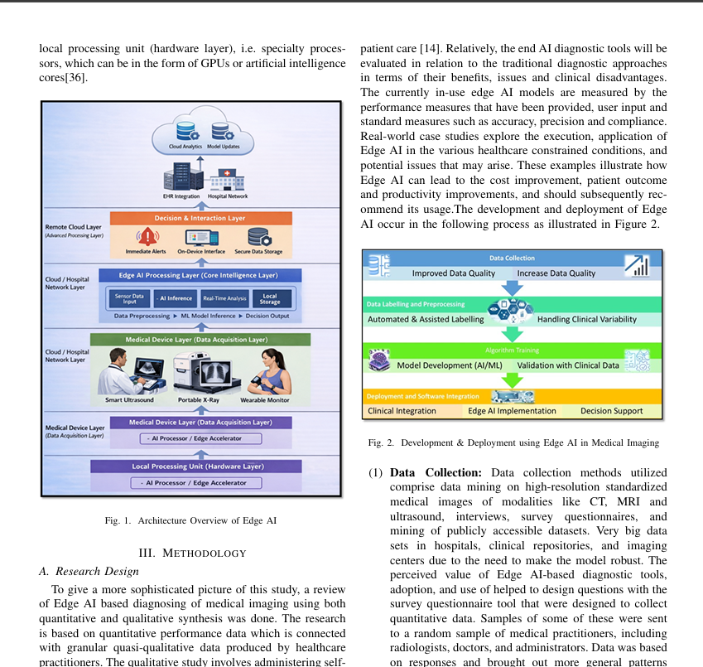
9
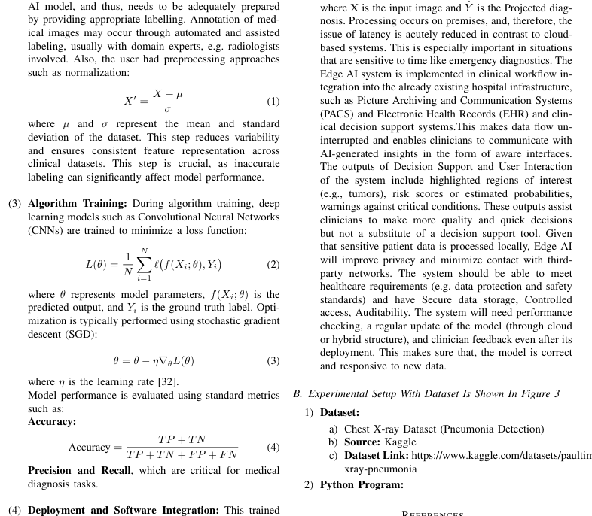

10
Conclusion
Edge AI has the potential to revolutionize healthcare diagnostics by enabling fast, accurate, and real-time medical image analysis. The integration of Artificial Intelligence (AI) and Machine Learning (ML) with medical imaging technologies significantly improves disease detection, reduces human errors, and enhances treatment decisions. Advanced deep learning models such as Convolutional Neural Networks (CNNs) can efficiently identify abnormalities in MRI, CT scans, X-rays, and ultrasound images with high precision.
The study demonstrates that Edge AI systems provide better efficiency, privacy, and reliability compared to traditional cloud-based systems. Since data is processed locally on healthcare devices, Edge AI reduces latency and enables instant diagnosis without depending heavily on internet connectivity. This makes the technology highly useful in emergency situations, rural healthcare centers, and remote areas where network access may be limited.
Furthermore, local data processing improves patient privacy and security by minimizing the transfer of sensitive medical information to external servers. Integration with Electronic Health Records (EHR) and clinical decision support systems also supports personalized healthcare and helps doctors make more informed clinical decisions. Overall, Edge AI enhances the quality of healthcare services, increases operational efficiency, and has the potential to transform the future of smart healthcare systems worldwide.

11
Future Scope

- Development of more advanced AI algorithms for disease detection.
- Integration with wearable healthcare devices for continuous patient monitoring.
- Improvement in real-time diagnostic systems for faster medical decisions.
- Better security and ethical frameworks for protecting patient data privacy.
- Expansion of Edge AI applications in remote and rural healthcare services.
- Use of federated learning for collaborative and secure healthcare models.
- Development of lightweight AI models for portable and low-power medical devices.
- Enhancement of predictive analytics for early disease identification and prevention.
- Increased use of AI-powered robotic assistance in surgeries and medical procedures.
- Integration of Edge AI with Internet of Medical Things (IoMT) devices.
- Improvement in personalized treatment planning using patient-specific data analysis.
- Reduction in healthcare costs through automated diagnostic and monitoring systems.
- Development of smart emergency healthcare systems with instant response capabilities.
- Better interoperability between AI systems, hospitals, and healthcare databases.
- Continuous improvement in deep learning models for higher diagnostic accuracy.

12
References

- D. Arora, D. Sharma, A. Sharma, and P. Goyal, “Redefining Disease Assessment in Raspberries: A Hybrid GAN-SVM Model for Detailed Intensity Measurement,” in 2024 4th International Conference on Ubiquitous Computing and Intelligent Information Systems (ICUIS), IEEE, 2024, pp. 621–625.
- D. Arora, K. Mehta, A. Kumar, and S. Lamba, “Evaluating Watermelon Mosaic Virus Seriousness with Hybrid RNN and Random Forest Model: A Five-Degree Approach,” in 2024 11th International Conference on Reliability, Infocom Technologies and Optimization (ICRITO), IEEE, 2024, pp. 1–5.
- A. Esteva et al., “A guide to deep learning in healthcare,” Nature Medicine, vol. 25, no. 1, pp. 24–29, 2019.
- S. McKinney et al., “International evaluation of an AI system for breast cancer screening,” Nature, vol. 577, no. 7788, pp. 89–94, 2020.
- World Health Organization, Ethics and Governance of Artificial Intelligence for Health: Large Multi-modal Models, WHO Guidance, 2024.
- M. T. Contaldo et al., “AI in Radiology: Navigating Medical Responsibility,” Diagnostics, vol. 14, no. 14, 2024.
- M. Kaur, P. Kumar, and A. K. Gupta, “Survey on Various Feature Detection and Feature Selection Methods using Retinopathy Images,” in 2023 International Conference on IoT, Communication and Automation Technology (ICICAT), IEEE, 2023.
- W. Hsu, M. K. Markey, and M. D. Wang, “Biomedical Imaging Informatics in the Era of Precision Medicine,” Journal of the American Medical Informatics Association, vol. 20, pp. 1010–1013, 2013.
- A. Giardino et al., “Role of Imaging in the Era of Precision Medicine,” Academic Radiology, vol. 24, no. 5, pp. 639–649, 2017.
- W. Shi, J. Cao, Q. Zhang, Y. Li, and L. Xu, “Edge Computing: Vision and Challenges,” IEEE Internet of Things Journal, vol. 3, no. 5, pp. 637–646, 2016.
- J. S. Hwang, K. H. Lee, and M. J. Kim, “Recent Advances in AI-Enhanced Fluoroscopy for Medical Imaging,” IEEE Transactions on Medical Imaging, vol. 39, no. 8, pp. 2103–2115, 2021.
13
- H. Litjens et al., “A Survey on Deep Learning in Medical Image Analysis,” Medical Image Analysis, vol. 42, pp. 60–88, 2017.
- A. S. Jagoda et al., “Clinical Policy: Neuroimaging and Decisionmaking in Adult Mild Traumatic Brain Injury in the Acute Setting,” Annals of Emergency Medicine, vol. 52, pp. 714–748, 2008.
- G. Litjens et al., “A Survey on Deep Learning in Medical Image Analysis,” Medical Image Analysis, vol. 42, pp. 60–88, 2017.
- J. Lu et al., “SuPer Deep: A Surgical Perception Framework for Robotic Tissue Manipulation using Deep Learning,” arXiv preprint arXiv:2003.03472, 2020.
- S. Hussein et al., “Lung and Pancreatic Tumor Characterization in the Deep Learning Era,” arXiv preprint arXiv:1801.03230, 2018.
- M. Schürch et al., “Towards AI-Based Precision Oncology,” arXiv preprint arXiv:2402.12190, 2024.
- P. Dhiman et al., “Analyzing Breast Cancer Detection,” in 2023 6th International Conference on Contemporary Computing and Informatics (IC3I), IEEE, 2023.
- H. Singh et al., “Investigations on Genetically Engineered Bioweapons Computer Based Techniques,” Vice Chancellor’s Message, vol. 1.
- D. Arora et al., “Evaluating Watermelon Mosaic Virus Seriousness with Hybrid RNN and Random Forest Model,” in ICRITO, IEEE, 2024.
- P. Kaur et al., “Convolutional Neural Network based Novel Automatic Recognition System for License Plates,” in ICCMST, IEEE, 2021.
- R. R. Kumar et al., “Enhancing Precision in Papaya Crop Health Management,” in ICITEICS, IEEE, 2024.
- V. Boboyev, “Microtonal Intonation and Ornamentation in the Kashkar Rubab Maqom Repertoire,” European Review of Contemporary Arts and Humanities, vol. 1, no. 4, pp. 35–44, 2025.
- C. Esposito et al., “AI in Robotic-Assisted Pediatric Surgery,” European Journal of Pediatric Surgery, 2025.
- J. Herington et al., “Ethical Considerations for Artificial Intelligence in Medical Imaging,” Journal of Nuclear Medicine, vol. 64, no. 12, pp. 1848–1854, 2023.

14
Appendices

Appendix A – Dataset Information
- Chest X-ray Dataset from Kaggle
- Used for pneumonia detection and model evaluation

Appendix B – Experimental Screenshots
- Python program screenshots
- Edge AI architecture diagrams
- Experimental setup images

Appendix C – Abbreviations
- AI – Artificial Intelligence
- ML – Machine Learning
- CNN – Convolutional Neural Network
- EHR – Electronic Health Records
- MRI – Magnetic Resonance Imaging
- CT – Computed Tomography
- PET – Positron Emission Tomography
- PACS – Picture Archiving and Communication System

15

